Moodle Course Content Access Control System

Version 1.0

Revision History

|  |  |  |  |
| --- | --- | --- | --- |
| **Date** | **Version** | **Description** | **Author** |
| 31/07/2013 | 1.0 | Requirement specification | Thilina Premasiri |
|  |  |  |  |
|  |  |  |  |
|  |  |  |  |

Table of Contents

1. Introduction 4

1.1 Purpose 4

1.2 Scope 4

1.3 Definitions, Acronyms, and Abbreviations 4

1.4 References 4

1.5 Overview 4

2. Overall Description 4

2.1 Product Perspective 4

2.2 Product Functions 4

2.3 Constraints 5

2.4 Assumptions and dependencies 5

3. Specific Requirements 5

3.1 Functionality 5

3.1.1 Add new content – select access level 5

3.1.2 Change access level 5

3.2 Usability 6

3.2.1 Time to learn should be less than 1 minute 6

3.2.2 User should clearly understand what new feature does 6

3.2.3 Intuitive user interfaces 6

3.3 Reliability 6

3.4 Performance 6

3.5 Supportability 6

3.6 Design Constraints 6

3.7 Interfaces 7

3.7.1 User Interfaces 7

3.7.2 Hardware Interfaces 7

3.7.3 Software Interfaces 7

3.8 Licensing Requirements 7

# Introduction

## Purpose

The purpose of this document is to present a detailed description of the “Moodle Course Content Access Control System”. It will describe the purpose and features of the system, the user interfaces, dependencies and constraints under which it must operate. This document is intended for both the developers and stakeholders of the system.

## Scope

Moodle Course Content Access Control System is intended to give a more flexible access control mechanism to course conductors who use the Moodle. This system may allow course conductors to decide which content should be publically available and which should be only visible for enrolled students.

More specifically this system is designed to encourage free education by making educational content available to the general public. Also this system helps to promote the courses conducted by educational institutes or individual teachers who use Moodle.

## Definitions, Acronyms, and Abbreviations

CCAC: Course Content Access Control System

## References

IEEE. IEEE Std 830-1998 IEEE Recommended Practice for Software Requirements Specifications. IEEE Computer Society, 1998.

## Overview

The next chapter, overall description section describes the functionality of the system. It describes the informal requirements and is used to establish a context for the specific requirements defined in detail in section 3.

Third chapter, Specific requirements primarily intended for the system designers and developers and defines requirements in detail.

# Overall Description

## Product Perspective

CCAC is a plugin for the Moodle. Moodle is a content management system which is specifically designed for managing educational course contents. CCAC is a subsystem in the Moodle which is intended to give a more flexible access control mechanism for moodle course conductors.

In a moodle course, the each content of the course belongs to either a resource or an activity. The access control facility will be provided to both of these content types.

## Product Functions

* At the time the course conductor add a new content to the course, there will be an option to select whether it is public or only visible to enrolled users.
* After some content is added, course conductor still able to change the access levels using this system.

## Constraints

Since this is an extension of an existing system, the developer has to comply with the architecture of the system and can’t violate it. For example, data retrieval and storing should done using the existing classes build into moodle system.

## Assumptions and dependencies

In this project, the developer has to assume that the general design of the moodle database will not change as the moodle evolve. If it changed, the CCAC has to change accordingly.

# Specific Requirements

## Functionality

This section defines all the functional requirements in detail

### Add new content – select access level

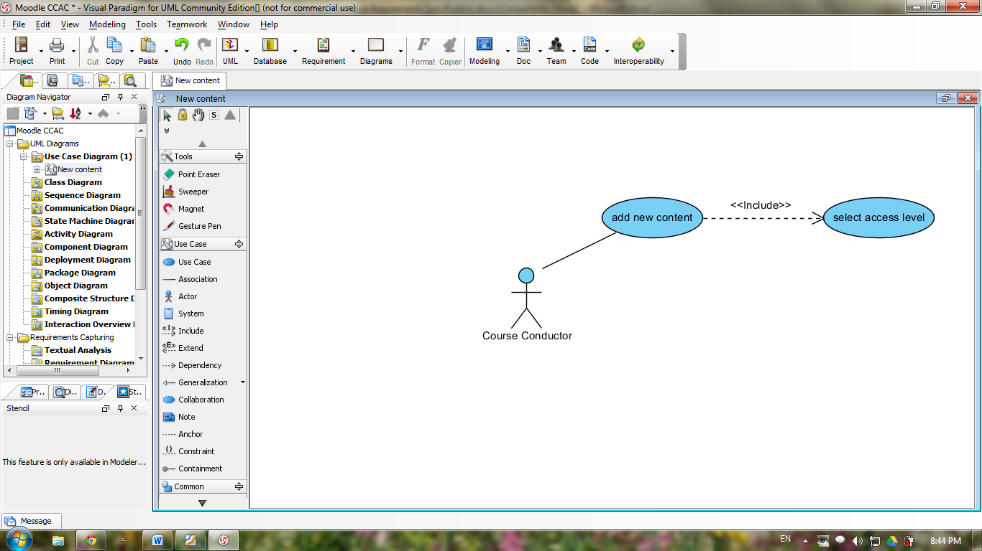

Add new content use case is already implemented in the existing moodle system. In this project, we have to implement a method to select access level for the content to be added. The access levels would be,

1. Only visible to enrolled users
2. Visible to all (publically available)

### Change access level

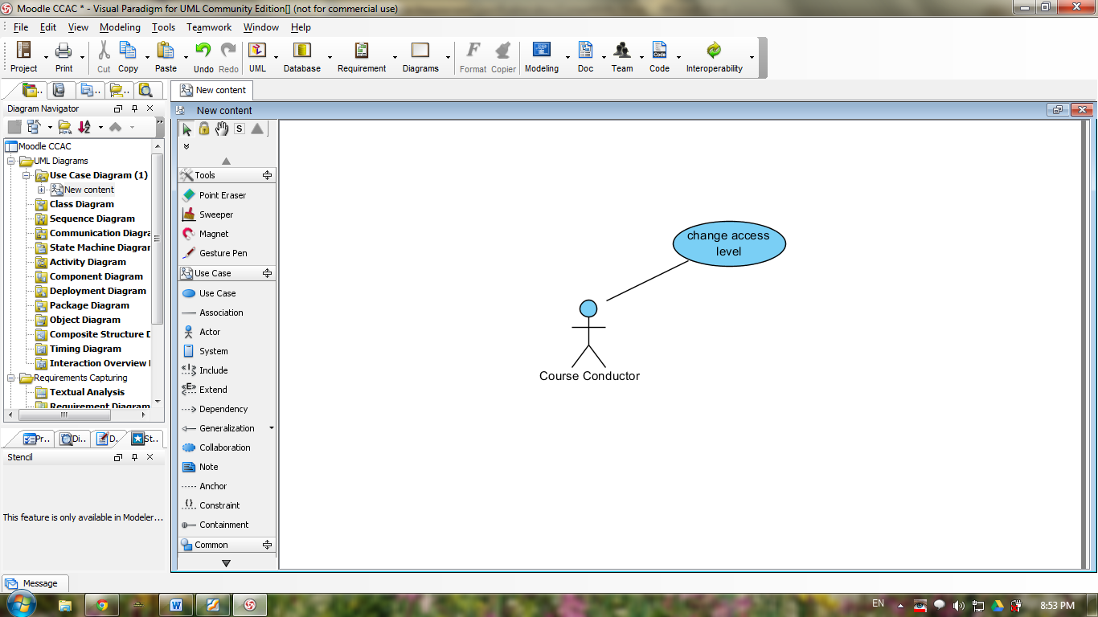

This is completely a new feature added by the CCAC to the Moodle. The course conductor should be able to change acces level any time using this feature. As described in the following image, there should be a new button to toggle the access level for each resource or activilty in the course.

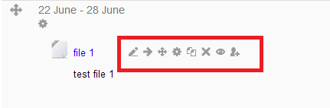

## Usability

In most cases, this systems will be used by users already familiar with the moodle. so it would take no time to learn new features added by this system. Even for a completely new user it wouldn’t take a considerable extra time to learn the features added by CCAC in addition to the time to learn default features in Moodle.

### Time to learn should be less than 1 minute

User should understand what the new feature will do in no time. This could be enabled by viewing description when hover the mouse over the toggle access level icon.

### User should clearly understand what new feature does

User should be clearly know what does the new feature do. We can make sure this by showing a little description along with the option to select access level

### Intuitive user interfaces

The new feature should not spoil the existing user interfaces of the moodle.

## Reliability

* The system should not introduce any bugs to the Moodle system
* The new feature should be 100% available

## Performance

* The CCAC enabled system should not increase the time taken to load a course more than 20ms compared to default Moodle system
* The network bandwidth usage for the new feature should be minimal

## Supportability

A complete online documentation for the system should make publically available so that anyone interested it the project can contribute in evolving and improving the product.

## Design Constraints

* Since this system is built on existing Moodle system, it should comply with existing system.
* Should not spoil the user interfaces of the existing system.
* The CCAC should design according to the architecture of the Moodle system

## Interfaces

### User Interfaces

* The CCAC will add new option(check box) to the add new content window to mark if it is publically available.
* As in the following figure, there will be an icon to toggle access level for each resource or activity in a course. This will be visible to the course conductor when editing is on



### Hardware Interfaces

There is no hardware interfaces for this system

### Software Interfaces

Since this is a plugin, there is no software interfaces too.

## Licensing Requirements

The system will be licensed under GPL so that other developers will be able to contribute to the system and it will be free